**The Magic Box by Evie Gibb**

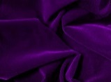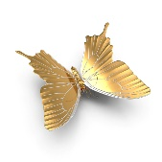I will put in the box

the soft velvet twilight,

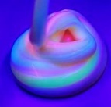violet glow-in-dark slime,

five golden butterflies.

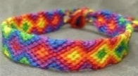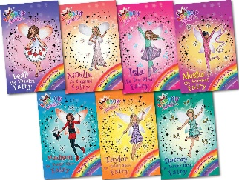I will put in the box

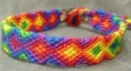a pair of friendship bracelets,

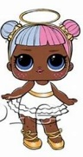my favourite book,

glittery, pocket-sized lols.

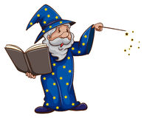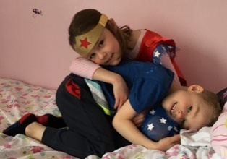I will put in the box

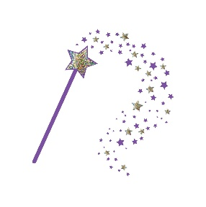cuddles from my brother,

the first spell of a wizard,

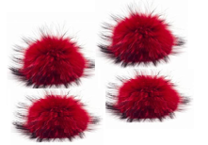a magic wand.

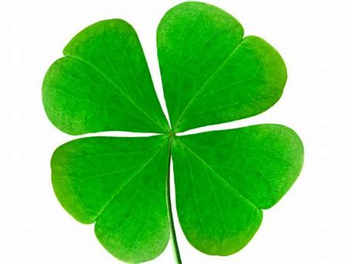

My box is fashioned from wood, pompoms and four-leaf clovers.

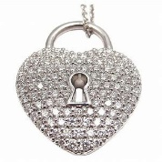With magic dust on the lid and a lock made of diamonds.

Its handle is made from rainbows.

