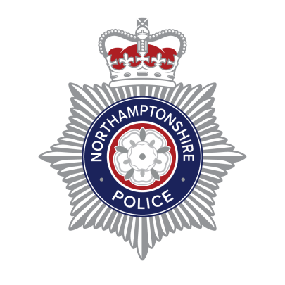 **Daventry Rural Neighbourhood Policing Team**

* Daventry Police Station

New Street

Daventry

NN11 4BS

Telephone 101 for non- emergency

Follow us on Twitter **@NorthantsPolice**

**07/10/2020**

Dear Parent/Guardian,

We understand many parents are looking for some guidance around trick or treating this Halloween with the current Covid-19 restrictions in place.

In line with the ‘Rule of Six’ legislation, people will NOT be able to hold Halloween parties and trick or treating is unadvisable therefore we have offered an alternative solution so that your children aren’t missing out this year but are still able to remain safe.

An alternative approach suggested for parents draws on the rainbow challenge which proved so popular in the spring. People who wish to be involved in Halloween can display pumpkins or pictures of the vegetable in their windows in the run-up to October 31. Parents/guardians can then take a walk around their local area with their dressed-up children and try to spot them and for each pumpkin/decoration spotted, offer the child a treat in return.

There are a number of pumpkin posters for children to colour in and ‘No Trick or Treating’ signs which are both available to download and print from the Northamptonshire Police website.

We urge parents of older children to talk to them about why it’s advised they don’t take part in trick or treating this year and to respect a resident’s decision if they choose not to take part. Anti-social behaviour is not acceptable and additional police patrols will be taking place during the Halloween period.

This advice is subject to change, should the guidance/legislation from Government change before October 31, 2020.

Kindest regards,

Daventry Rural Neighbourhood Policing Team

[NeighbourhoodTeamDaventry@northants.pnn.police.uk](mailto:NeighbourhoodTeamDaventry@northants.pnn.police.uk)

