ADULT GUIDANCE
Goodnight Mr Tom
Chapter Ten

Comprehension section A to D
Each section increases in difficulty, please allow children to work as far as they can independently and help only when required.
Challenge Activities
Challenge activities also appear in order of increasing difficulty, again please allow children to complete as much as possible independently.
Section A:
(Q1) What is Zach describing as a ‘fossil on wheels’? May Thorne’s bicycle.
(Q2) For what reason did Willie think Zach’s bedroom was like a study? It was full of books and contained a desk.
(Q3) Why does George want Zach to hurry opening the case? He was desperate to see inside the case and what was sent but knew he could not stay long at Zach’s house.
(Q4) Why did Zach beam when Willie said his dancing was fine? He was proud and pleased that Willie thought he was good at tap dancing.
(Q5) How did Tom know that something was up with Willie? He said he had a brown cloud over him since supper. He knew Willie wasn’t acting himself.
(Q6) How had Tom supported Willie in learning to read and write at home? He helped him every evening with his writing. He also put labels up around the house so that Willie could read the words next to the objects.
Section B:
(Q7) Why is Willie described as ‘faithfully’ practicing his writing every day? What type of word is it? He ensured he practiced every day. It is an adverb.
(Q8) How do you know that ‘ To Save His Chum ’ is the name of a book? It is written in italics and each word starts with a capital letter to show it is a title.
(Q9) Why did Willie misunderstand what a play was? Willie did not know what a play script was and had never seen a script or play before. He associated the word play with something that children do.
(Q10) Why is there a line of stars? It shows that there is a change in the chapter such as mood or location.
(Q11) What is meant by the term ‘dared not venture’? They did not have enough courage to venture or explore.
(Q12) Why was Willie so keen to learn to write? He wanted to join the class with his friends and children of his own age.

Section C:
(Q13) Why might Charlie Ruddles wag his finger at them if they do not put up the blacks? He is the warden and ensures that no light escapes any of the houses when it is dark. This is so that enemy planes cannot spot them.
(Q14) What does Zach mean when he says ‘rot’? It is an old term used to show you think something is nonsense or rubbish.
(Q15) Why did Mrs Little appear with a piece of ceiling plaster in her hand? Zach’s dancing upstairs had caused vibrations and had made some ceiling plaster fall down.
(Q16) Why does Carrie joke about Mr Ruddles and Zach’s new jumper? The jumper is very bright. Mr Ruddles ensures no bright lights are visible when it is dark so Carrie is implying it is so bright that Zach may need to cover it with blackout material.
(Q17) Why does George think that the War hasn’t even begun yet? They were so far away from the effects of the war and were somewhere relatively safe.
(Q18) Why does the phrase ‘Admired him!’ have an exclamation mark? Willie is surprised that his friend Zach admires him. It shows that he is surprised at this.
Section D:
(Q19) What words are used to describe how excited the children are at this point in the text? Scrambled, leapt, excitement, clattered. These words show that they are energetic in their actions.
(Q20) Why does Carrie say to Zach, “you’re just an angel, ent you”? She is being sarcastic. She is joking with him and does not think he is really angel-like.
(Q21) What things may make Zach realise that the other children are different to him? They do not know who some people he’s talking about are. They have never been to a show and are fascinated with the costumes and props. The others do not seem as interested in books as Zach.
(Q22) What is Zach referring to when he is pointing with his thumb to the floor? He is suggesting that the problem with meeting at his house is Mrs Little, who at that time was downstairs.
Challenge Activities
Section A:
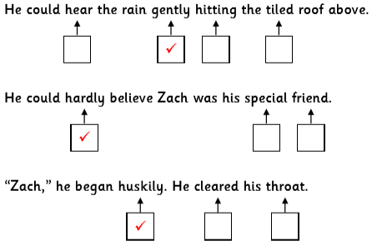

Section B:
Any suitable synonyms will work, ensure that the sentence makes sense.
Section C:
Meanwhile, the Government had asked for a money contribution from the parents of evacuees.
Zach gave her a withering glance but it was so dramatic she and the others burst out laughing.
He peeled a large piece of newspaper from the top and unwrapped five small parcels.
Section D:
