Minibeast Hunt
Lots of Ants
A Fly
A Wasp
3 Frogs
7+ Newts
2 Snails
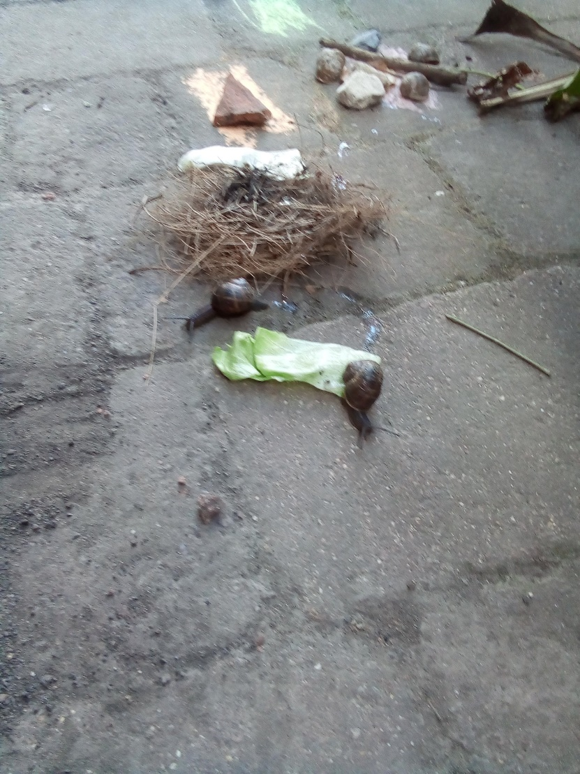
We kept pet snails for only 30 minutes.

8+ Baby Mosquitos
A Spider
A Dragon Fly
A Large Red Damselfly
A Fruit Fly
A Flying Ant
Loads of peacock butterfly caterpillars
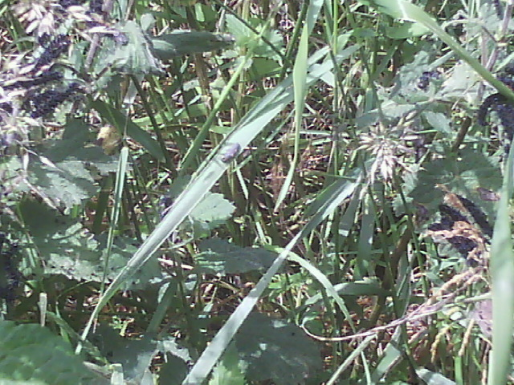
Peacock Butterfly caterpillars Like to eat stinging nettles.
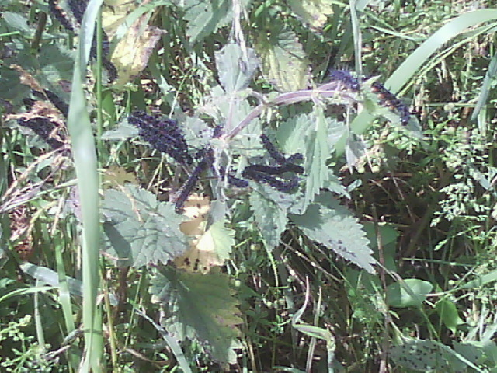
On our walk we saw loads of caterpillars.

