ADULT GUIDANCE
Goodnight Mr Tom
Chapter Ten

Comprehension section A to D
Each section increases in difficulty, please allow children to work as far as they can independently and help only when required.
Challenge Activities
Challenge activities also appear in order of increasing difficulty, again please allow children to complete as much as possible independently.
Section A:
(Q1) Why is the tree described as half-naked? It has lost a lot of its leaves.
(Q2) Why is Zach’s jersey named the ‘joseph’ jersey? It is like Joseph’s technicolour dream coat. It is bright and multi-coloured.
(Q3) Why does Zach compare the light to ‘rays from heaven’? The light is coming from above in the roof, causing a large ray into the darkness where they stood.
(Q4) Why did Ginnie gasp when she heard about the Christmas show? Zach had implied that they help out and Ginnie hates going on stage.
Section B:
(Q5) Why was Willie’s stomach growing tighter? He was nervous about his friends coming round.
(Q6) Why did the other children like Willie’s room so much? They were impressed with Willie’s drawings which were on the walls. They thought it was beautiful and very different to the rooms they had.
(Q7) Why does George think reading books are pointless? He does not see why you need to learn to read to take care of animals and to farm.
(Q8) Why was Willie asked to do all the illustrations for the newspaper? He was known in the group to be good at drawing.
Section C:
(Q9) What is meant when the text says that Tom ‘leaned across the gate in a confidential manner’? He is leaning in a way that means he can talk more quietly. He does not want everyone to know what he is about to say.
(Q10) What is meant by the term ‘insipid’? Thin and weak, often lacking interest.
(Q11) Why is Willie alarmed that Zach is not a Christian? He was brought up by his mother to be a devout Christian. It has been implied previously that she is very strict.
(Q12) Why did they all stare at Willie when he announced he would like to go looking for badgers? It was unusual for him to volunteer for something without being talked into it.

Section D:
(Q13) Why is Carrie annoyed that girls are treated differently? Girls don’t have the same opportunities as the boys. She really wants to learn yet George who has more opportunities does not seem to want to learn. She wants to join the choir but only boys are allowed to.
(Q14) How does Zach feel about being shouldered out of the play because he is Jewish? He does not understand why. He knows the story very well and argues that Judaism is just as important as Christianity.
(Q15) How does Zach inject some fun into the meeting? He tries to frighten the others by pretending to be a ghost.
(Q16) What thing at the end of the chapter shows how Willie is feeling? The lack of bed-wetting shows that he is happy and comfortable at Tom’s house. He is pleasantly surprised that he has not wet the bed.
Challenge Activities
Section A:
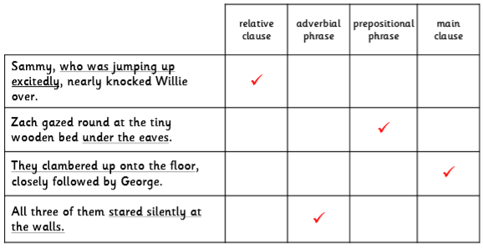

Section B:
They agreed that Willie would draw the illustrations.
Although Willie was embarrassed, they agreed that Willie would draw illustrations.
He fell asleep in the chair
He fell asleep in the chair because he was exhausted
Zach persuaded them to visit the old cottage
After some theatrics, Zach persuaded them to visit the old cottage
Section C:
1 – C
2 – E
3 – D
4 – A
5 – B

Section D:
Personal response; ensure the summary includes the three main events of the chapter:
- Willie is almost ready to move up to the next class with his friends.
- Willie’s friends come to see his room and they plan the Gazette.
- Willie wakes up and realizes he hasn’t wet the bed.

