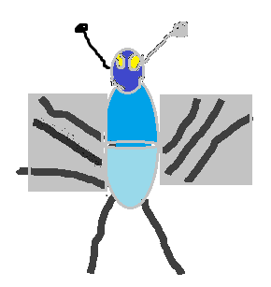
KIAN’S

MINI- BEAST GUIDE
Name | Photo | Habitat
Black Ant | 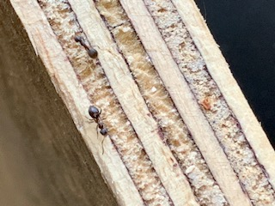 | - Open area  - Underground  - Under stones  - Rotten wood  - Under roots
Broad-Winged Damselflies | 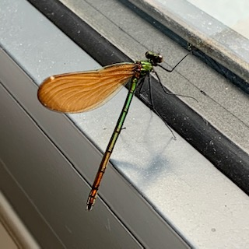 | - Gardens  - Streams  - Creeks
Crane Fly or Daddy long legs | 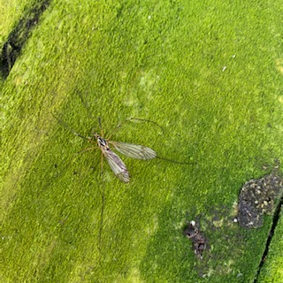 | - Forest  - Fields  - Streams  - Vegetation  - Tree trunks  - Ground  - Woody matter
Bumblebee | 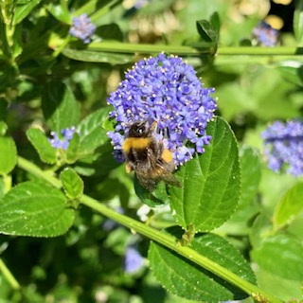 | - Field  - Park
Forest Cockchafer | 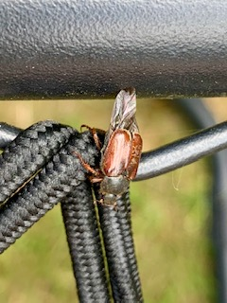 | - Crop  - Woodland
Garden Snail | 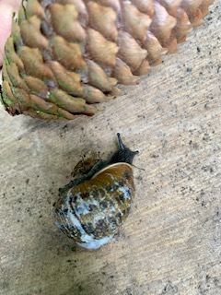 | - Park and gardens at night  - Rotten garden matter  - Hedgerows  - Marshes  - Woodlands  - Ponds  - Garden Furniture
Honey bee | 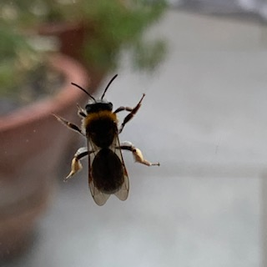 | - Wood land  - Wild flower
House Fly | 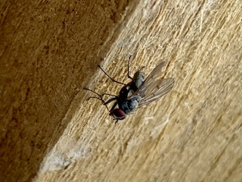 | - Rural area  - Urban areas
Large red Damselfly | 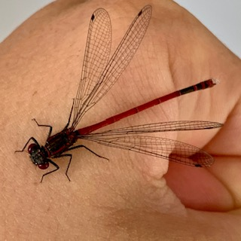 | - Ponds  - Rivers  - Wetland
Orb Weaver | 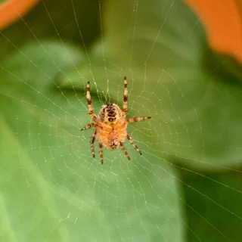 | - Garden  - Wooded area
Privet Hawk Moth | 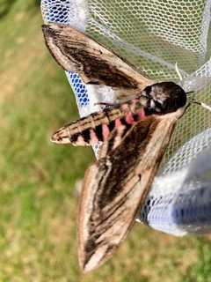 | - Urban area  - Forest  - Wood land
Small Dusty Wave Moth | 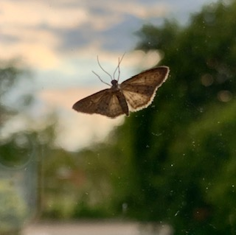 | - Garden  - House  - City
Wood Louse | 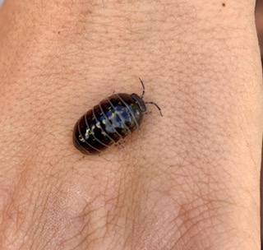 | - Leaf  - Under Stone  - Garden  - Leaf litter  - Grass  - Hedgerow  - Wall
Asian Trampsnail | 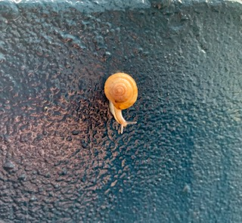 | - Garden  - Greenhouses
Marbled cellar spider | 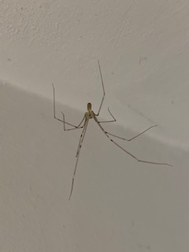 | - Houses  - Exposed areas
Tapered drone fly | 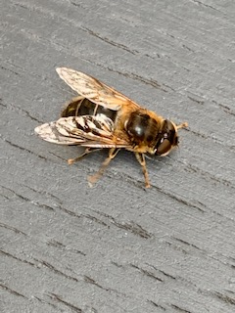 | - Wetland  - Forest  - Farmland  - Gardens  - Parks
Garden Slug | 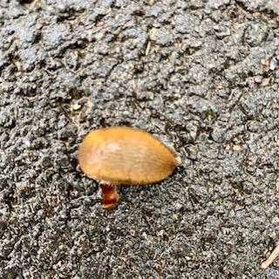 | - Woods  - Fields  - Garden
Black Millipede | 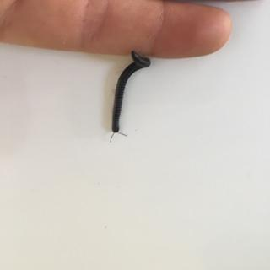 | - Garden  - Tree litter

