Canada Project:
Edward Benting:
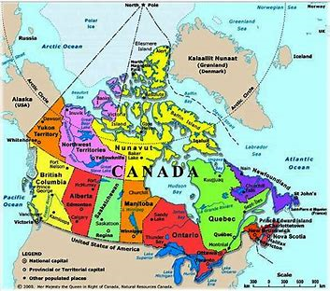

I wanted to do my project about Canada, as my dad has been there for work and I really liked all the photo’s he showed me. I really want to go there one day and would love to learn how to snow boardit. People from Canada have a funny accent. I love having Canadian maple syrup on pancakes, but it must be the original pure one. Maple syrup comes from a maple tree. They have maple tree farms. The farmer taps holes in the tree and then they insert a tap with a bucket tied onto it. They then leave it and the syrup drains into the buckets. It is very sweet. Pure Canadian syrup is clear not brown like the ones you sometimes see in our shops.
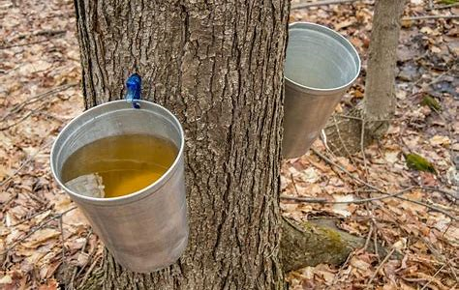

Canada was a British Colony and our Queen is still their queen. They are part of the Commonwealth. Their government is very similar to our government, and they also have a prime minister, a parliament and a house of lords and commons. Their laws are also based on English laws.
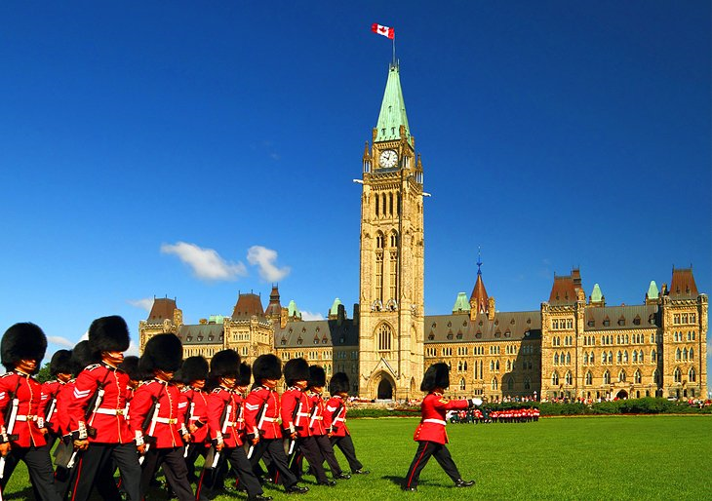

Canada sits above America and is very big. A huge part of the country has no people living there. So, it has wide open spaces that people cannot live on. 90% of all Canadians live within 100 miles of the American border. Canada is a country of majestic landscapes of fjord-lashed coastlines and glistening lakes, snow capped mountains, deep green forests and busy city lights. In Canada they speak French and English.
They also had native people living their hundreds of years ago called Canadian Aboriginals, Indians or Inuits
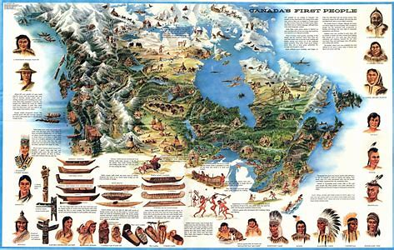

The Canadians are very good at winter sports and their national sport is Ice Hockey in the Winter and Lacrosse in the Summer. They do very well in the winter Olympics, as a big part of the country is covered in snow and ice for most of the year.
Lacrosse is a very strange looking sport. It is a sport that was played by the native people originally. It is a stick with a net on the end and players flip a ball to their teammates. It looks very dangerous.
They do allot of outdoor activities, like mountain climbing, skiing, camping. You can also fish wild salmon in the lakes and rivers.
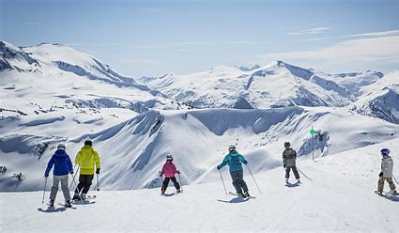

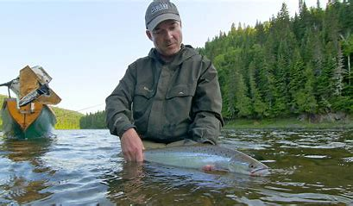
The police are called the Mounties and they are famous for being on horse backs as the terrain is so rough that it is easier to navigate on a horse. They are now using 4x4s as well
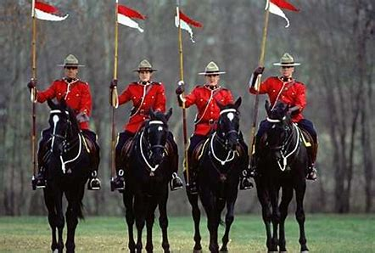
The National Flag of Canada, though simple with its red and white colours and a single maple leaf, symbolizes pride and strength throughout Canadian history.
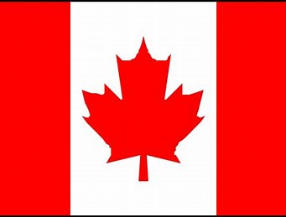

Canadian money is called the Canadian Dollar. You can get them in CA$5, CA$10, CA$20, CA$50, and CA$ 100-dollar notes. The CA$1 and CA$2 bills have been replaced with coins (the loonie and the toonie). Canadian bills are brightly coloured making them easy to distinguish from one another.
Ottawa is the capital city of Canada. It stands on the south bank of the Ottawa River in the eastern portion of southern Ontario
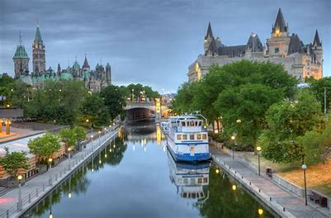
Other famous Canadian Cities are Montreal, Toronto and Vancouver.
Another place I would really like to see one day is the Niagara Falls. It is so big, and they say that the noise is so loud! Bridal Veil Falls are the smallest of three waterfalls and Horseshoe Falls is the largest. Combined, the three waterfalls that make up Niagara Falls produce the world's highest flow rate. They make electricity with the energy the water generates.
