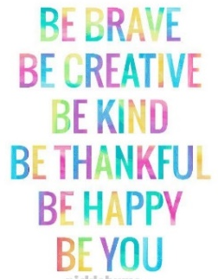
Dear Year 2,
Firstly, we would like to say how much I am looking forward to seeing all the super things you have been doing and will be doing over the coming weeks.
Now we have given you some ideas on work you can do, but unfortunately your grown-ups don’t know how to work as a year 2! So here is the challenge YOU need to help them (did they just ask why that word was in bold and capital letters?)
Over the next couple of weeks you have all the spellings and the patterns we have looked at in class. Words that we might find useful but are tricky to spell, keep working on them! As well as the high frequency and common exception words! Think of some funny sentences and test your parents on them also.
In class we are reading ‘The Hen Who Wouldn’t Give Up.’ Hilda had tried a number of ways to get to the village Little Dollop to visit her auntie. Can you think of a way for her to get there and write an ending for the story? Think of what has already happened (you will have to tell your grown-ups) we can’t wait to read your ideas!
We started to talk about non-chronological report writing. This is using our research skills, finding facts and putting them together to make a display or report, using headings, diagram and captions. The tricky part is teaching your grown-ups all the things we have to use in our writing. When to use capital letters, full stops, commas in lists, expanded noun phrases and conjunctions and don’t forget, make sure you show them how you re-read your work to check it makes sense.
You can write your report about anything you like, some ideas could be, one of the seven continents, an animal, dinosaurs, a football team or dancing.
Keep working on your mathletics if possible and don’t forget how important it is to know odd and even numbers, number bonds, doubling and halving and how to add and subtract using tens and ones. Test your fraction knowledge on the mini test attached.
We know you are up to the challenge. Don’t forget to email your ideas to boughtonyr2@gmail.com
Have a super Easter! We miss you more than chocolate cake, look after your grown-ups.
Mrs Allen & Miss Goodman

